MA 323 (2020) Monte Carlo Simulation Lab 02

**Name:** Udandarao Sai Sandeep

**Roll Number:** 180123063

**Dept.:** Mathematics and Computing

**Q1.**

The First seventeen Values of the required series was calculated using Linear Congruence Generator.

Then, 1000, 10000, and 100000 values of Ui were generated using the lagged Fibonacci generator.

For each case, Frequency Bar Diagram was created, and Plot of (Ui, Ui+1) was also created.

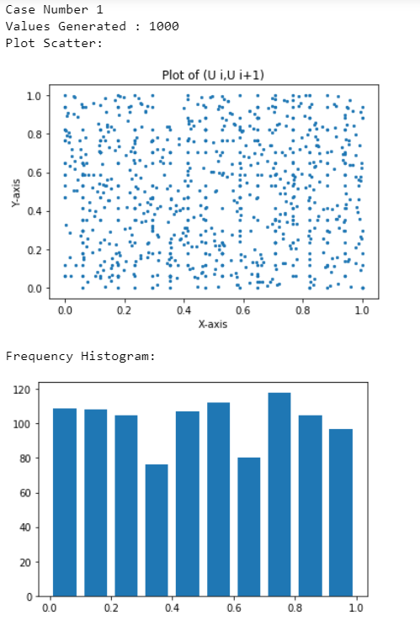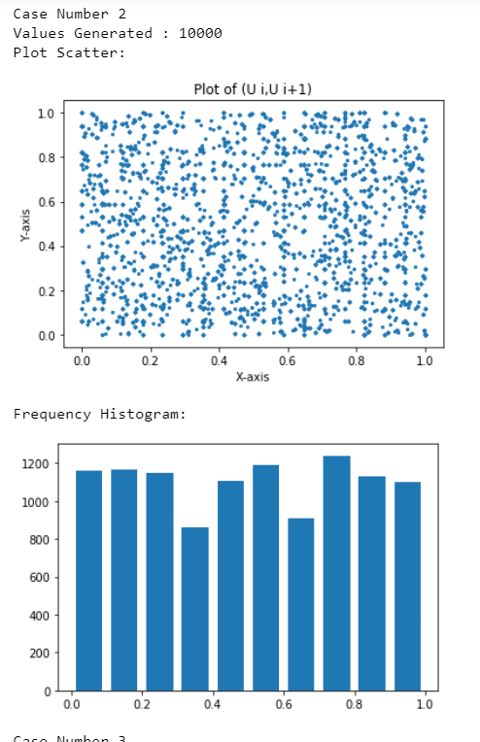

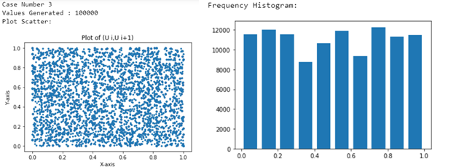

**Observations:** In contrast to Linear Congruence Generator, no clear pattern is observed in all the (Ui, Ui+1) plots, indicating that Ui+1 is not directly dependent upon Ui (which is evident from Formula for lagged Fibonacci Generator). The points fill the entire 1*1 square almost uniformly, hence mimicking uniformity and randomness. Also, as the number of values generated increases, the density of the plot increases as well.

Also, frequencies of each interval (Total 10 intervals equally spaced between 0 and 1) are somewhat equal (with a slight deviation of about 10% from central value). This indicates that lagged Fibonacci Generators tend to have much greater period length (for appropriate input parameters) as compared to Linear Congruence Generators.

**Q2.**

The Values of U were generated using Linear Congruence Generator.



In total, there are 8 cases. In each case, certain number of values of U were generated, which were further used to generate the values of X using the given formula. Then, the entire range of X was normalized to fit 0 to 1 Range, which was further divided into 20 equal intervals. Frequency of each interval was then calculated. Using the midpoints of interval as x coordinate, and frequency of the interval as y coordinate, a graph was plotted using the 20 points (joined with each other). This Graph denotes the Interval vs Frequency Graph. Using the midpoints of interval as x coordinate, and **cumulative** frequency of the interval as y coordinate, another graph was plotted using the 20 points (joined with each other). This Graph denotes the Interval vs Cumulative Frequency Graph. For each case, Sample mean and Sample Variance was also calculated using the 20 points. All the data is presented in table given on the next page.



Strictly Increasing Function

Using the Cumulative Distribution Function given above, a graph of the actual distribution Function was created.

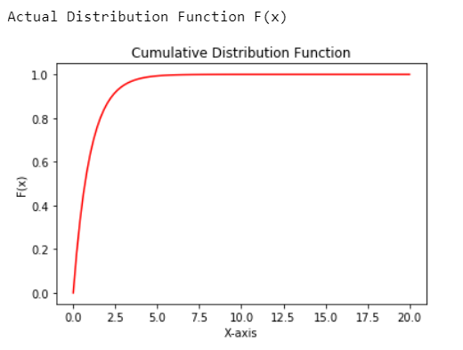

Actual Value of Mean = Theta = 1

Actual Value of Variance = (Theta)2 = 1

As depicted by the table given below, as the number of values generated increases, the cumulative Frequency vs Interval graph matches the graph of the Distribution function given above. The values of Sample Mean and Sample Variance converge to the Actual Mean and Actual Variance as the number of values generated increases.

The Interval vs Cumulative Frequency Graph converges to the above Cumulative Distribution Function because of the following result (stated in MA372 Stochastic Calculus):

Let X be a random variable uniformly distributed on [0,1]. If ***f*** is a strictly increasing distribution function, then the random variable Z = *f* -1(X) also follows the same distribution as that of ***f***.

**Table for Q2.**

|  |  |  |  |  |
| --- | --- | --- | --- | --- |
| No. of Values | Frequency vs Interval | Cumulative Frequency vs Interval | Mean | Variance |
| 20 |  |  | 1.213 | 2.786 |
| 50 |  |  | 1.002 | 1.389 |
| 100 |  |  | 1.007 | 1.328 |
| 200 |  |  | 1.083 | 1.326 |
| 500 |  |  | 1.035 | 1.032 |
| 1000 |  |  | 1.028 | 1.059 |
| 10000 |  |  | 1.005 | 1.023 |
| 100000 |  |  | 1.004 | 1.001 |

**Q3.**

The Values of U were generated using Linear Congruence Generator.



In total, there are 8 cases. In each case, certain number of values of U were generated, which were further used to generate the values of X using the given formula. Then, the entire range of X was normalized to fit 0 to 1 Range, which was further divided into 20 equal intervals. Frequency of each interval was then calculated. Using the midpoints of interval as x coordinate, and frequency of the interval as y coordinate, a graph was plotted using the 20 points (joined with each other). This Graph denotes the Interval vs Frequency Graph. Using the midpoints of interval as x coordinate, and **cumulative** frequency of the interval as y coordinate, another graph was plotted using the 20 points (joined with each other). This Graph denotes the Interval vs Cumulative Frequency Graph. For each case, Sample mean and Sample Variance was also calculated using the 20 points. All the data is presented in table given on the next page.

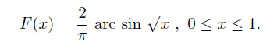

Strictly Increasing Function

Using the Cumulative Distribution Function given above, a graph of the actual distribution Function was created.

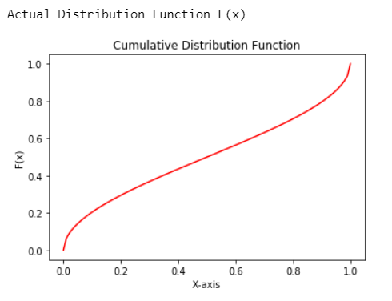

Actual Value of Mean = 0.5 (Calculated through Integration)

Actual Value of Variance = 0.125 (Calculated through Integration)

As depicted by the table given below, as the number of values generated increases, the cumulative Frequency vs Interval graph matches the graph of the Distribution function given above. The values of Sample Mean and Sample Variance converge to the Actual Mean and Actual Variance as the number of values generated increases.

The Interval vs Cumulative Frequency Graph converges to the above Cumulative Distribution Function because of the following result (stated in MA372 Stochastic Calculus):

Let X be a random variable uniformly distributed on [0,1]. If ***f*** is a strictly increasing distribution function, then the random variable Z = *f* -1(X) also follows the same distribution as that of ***f***.

**Table for Q3.**

|  |  |  |  |  |
| --- | --- | --- | --- | --- |
| No. of Values | Frequency vs Interval | Cumulative Frequency vs Interval | Mean | Variance |
| 20 |  |  | 0.491 | 0.108 |
| 50 |  |  | 0.504 | 0.100 |
| 100 |  |  | 0.505 | 0.115 |
| 200 |  |  | 0.524 | 0.123 |
| 500 |  |  | 0.519 | 0.124 |
| 1000 |  |  | 0.510 | 0.126 |
| 10000 |  |  | 0.501 | 0.124 |
| 100000 |  |  | 0.500 | 0.125 |